Hosting_hub application manly deployment,
First we need to create instance, [aws cloud ububtu]
Install java version 21,
sudo apt update
sudo apt install openjdk-21-jdk
java -version
cd /opt/hosting_hub/hosting-hub
chmod +x mvnw
check java versions setup the java 21 version,
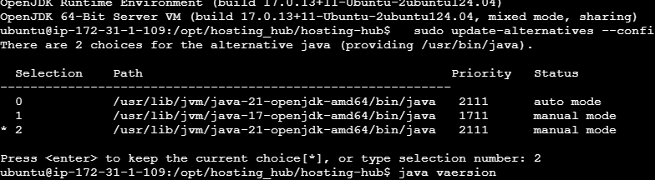

Setup the java home path, 21 version
nano ~/.bashrc
export JAVA_HOME=/usr/lib/jvm/java-21-openjdk-amd64
export PATH=$JAVA_HOME/bin:$PATH
sudo apt-get install maven
cd /opt/hosting_hub/hosting-hub
mvn -N io.takari:maven:wrapper
chmod +x mvnw
sudo mvn clean install === this is build run command,
now starting building,
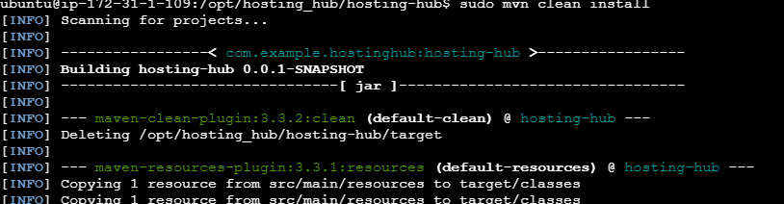
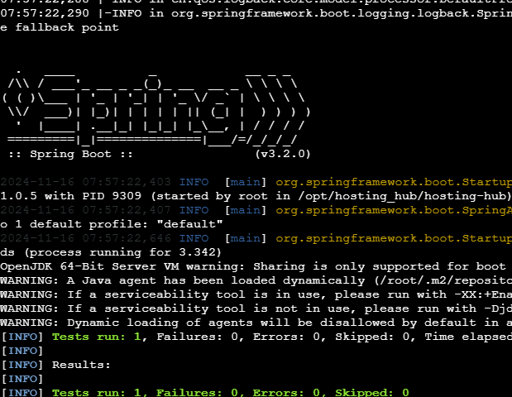
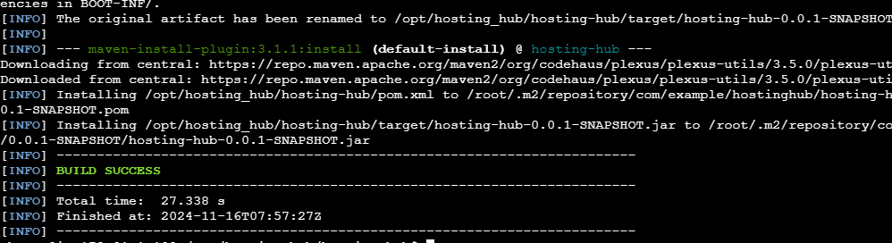
Backend build completed ,
======================#=========================#================================

Deploy the Frontend

Ui build,
Navigate to the Frontend Directory:

cd /opt/hosting_hub/ui
sudo apt update
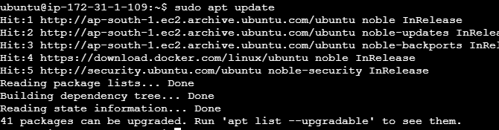

Step 2: Install Node.js and npm
You can install Node.js and npm using the default Ubuntu repository. Run the following command:

sudo apt install nodejs npm

Step 3: Verify the Installation
After the installation is complete, you can verify that Node.js and npm are installed correctly by checking their versions:

node -v
npm -v

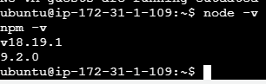

Configure Nginx (Optional)

If you choose to use Nginx to serve your frontend, follow these steps:

- Install Nginx:
sudo apt-get install nginx

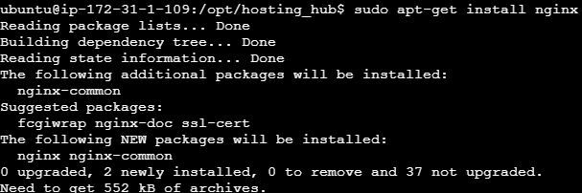

Configure Nginx: Create a new configuration file for your site:

sudo nano /etc/nginx/sites-available/your-site

Add the following configuration (adjust paths as necessary):

server {
listen 80;
server_name your_domain_or_IP;

location / {
root /opt/hosting_hub/ui/build; # Adjust to your build directory
try_files $uri $uri/ /index.html;
}

location /api {
proxy_pass http://localhost:8080; # Adjust to your backend port
}
}

Enable the Configuration:

sudo ln -s /etc/nginx/sites-available/your-site /etc/nginx/sites-enabled/

Test and Restart Nginx:

sudo nginx -t
sudo systemctl restart nginx

